DISCOTHEQUE LIGHT STROBOSCOPIC FLASHER

ABSTRACT

Stroboscopic lighting effects for discotheques are achieved by using conventional white LEDs replacing the discharge lamps for higher efficiency at low cost. This control is possible by instantly switching the LEDs on & off at higher voltages for less time period. This fast control of intensity from full glow to full off helps in developing a stroboscopic effect which is generally used in disco dance floors for better effects.
A programmable microcontroller from PIC family is engaged to provide such effect being driven by a MOSFET for cluster of LEDs. The controller according to the program generates ON/OFF commands at high rate thus giving the effect of stroboscopic lights. As the controller gives only 5v drive, it is not possible for the MOSFET to be reliably switched ON at that voltage. An interfacing transistor is used between the controller output and the MOSFET for driving the same.
The power supply consists of a step down transformer 230/12V, which steps down the voltage to 12V AC. This is converted to DC using a Bridge rectifier. The ripples are removed using a capacitive filter and it is then regulated to +5V using a voltage regulator 7805 which is required for the operation of the microcontroller and other components.

BLOCK DIAGRAM

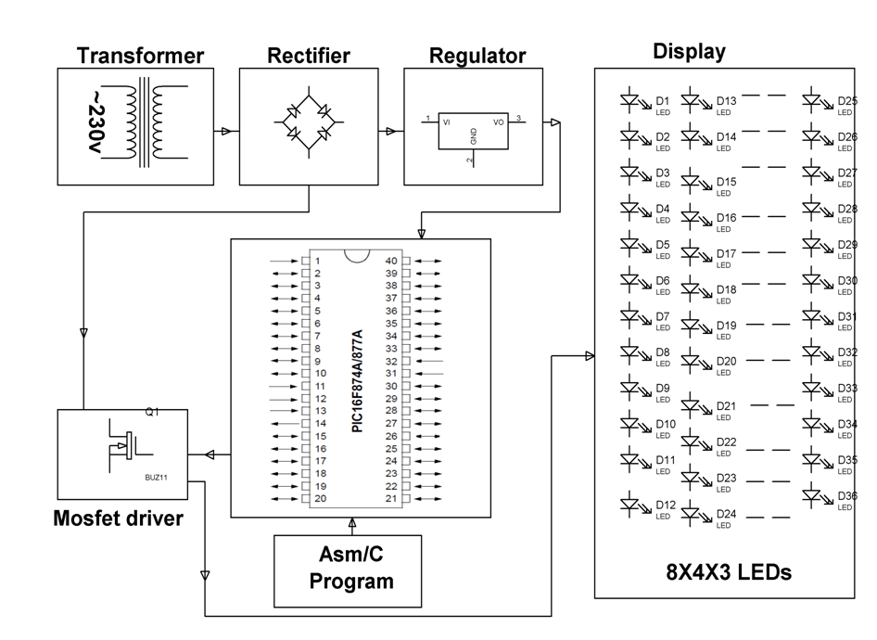

HARDWARE REQUIREMENTS:
Transformer, Diodes, Capacitors, Resistors, LED’S, PIC series Microcontroller, White LEDs, Mosfet, Crystal.
SOFTWARE REQUIREMENTS:
HI-TECH PICC Tool suite
Language: Embedded C or Assembly.

